Spectroscopy in a Suitcase: It’s ‘murder’ at DFEi for College Awareness Week!

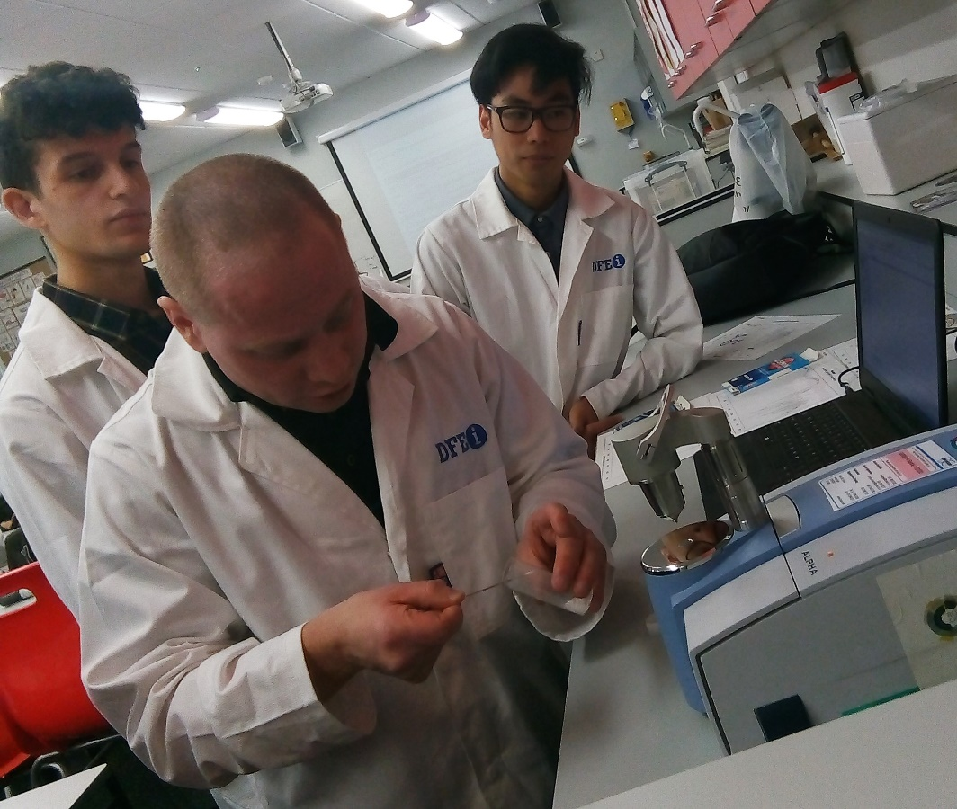
By Aisling O’Gorman, DFEi Journalism student.
Dun Laoghaire Further Education Institute briefly became a crime scene on Tuesday, when Dr John O'Donoghue, Education Coordinator for the TCD School of Chemistry, demonstrated his forensic sleuthing techniques to riveted DFEi Criminology students as part of College Awareness Week.
He began by explaining the science and tools of spectroscopy. This branch of chemistry is a non-destructive way of analysing bodily fluids and other forensic materials such as drugs or fingerprints.
The students were then divided into five groups, with each getting involved in "murder mystery forensics" using the evidence presented to them. Each group had to identify what substance was used in the “crime” and how much of it was in the victim's body (fictional, of course!). O’Donoghue explained that even a small error made by one group would affect the results.
The workshop concluded with O’Donoghue providing the students with resources to help in their future careers in Crime Scene Investigation.
He said the goal of the workshop was "putting into context that chemistry is not just science and arbitrary work in a lab… It actually has real world applications."

