WRITING ON THE WALL FOR COLLEGE AWARENESS WEEK
A colourful mural by Tadhg Burke-Kennedy marked the launch of College Awareness Week by Mary Mitchell O’Connor TD at DFEi, Dun Laoghaire
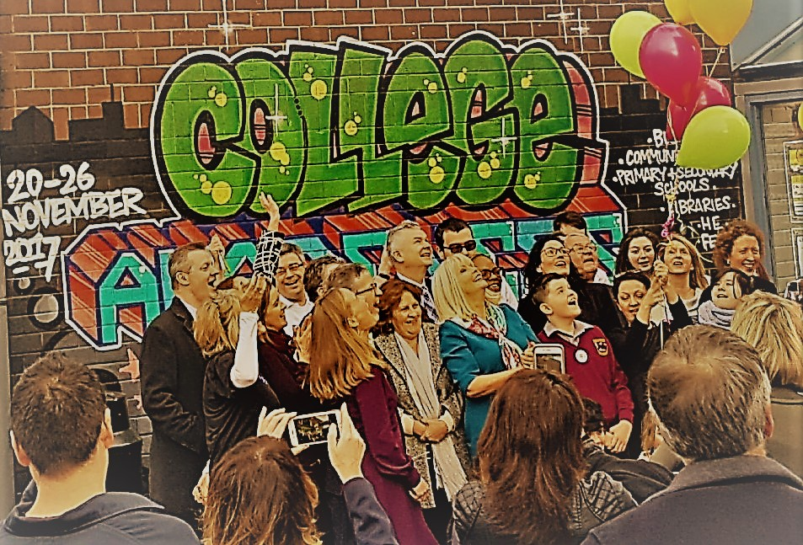

It was no ordinary graffiti on the wall of the DFEi (Dun Laoghaire Further Education Institute) on Monday morning November 20th. The giant-sized colourful letters – College Awareness Week – were part of unique artwork commissioned and created for the national campaign by muralist Tadhg Burke-Kennedy.
Minister of State for Higher Education, Mary Mitchell O’Connor TD, expressed her delight that her home turf had been chosen for the launch of the fourth College Awareness Week (CAW) campaign.
She said the issue of progression to college was close to her heart. “Education is an investment that pays massive dividends, and College Awareness Week aims to raise awareness of the opportunities available to every single student. Education is the key."
Ms Mitchell O’Connor stressed the Government’s commitment to increasing the number of students doing apprenticeships from 9,500 this year to 50,000 by 2020. She said further progress would be made this week on the passing of the Technological Universities Bill to help drive regional development and job growth.
Students from Scoil Cholmcille Senior Primary School, Ballybrack, and Cabinteely Community School were welcomed by DFEI students who helped to organise the event. The primary and secondary school students were given the opportunity to speak of their hopes, dreams and career goals, which spanned the industries of Architecture, Film Studies and Science.
Dr Grainne Quinn, Executive Vice President and Chief Medical Officer of Perrigo, chief sponsors of College Awareness Week and global suppliers of healthcare products, spoke about Perrigo’s “vested interest in developing native talent in Ireland’. She said that in some areas progression to college was as low as 26%, and such numbers had to be addressed as college “should be available to all.” Dr Quinn said that College Awareness Week played its part but “funding students hoping to attend third level education” was the key to progress.
Campaign founder Kathleen O’Toole of the Trinity Access Programme, asked about the financial difficulties students faced by students looking to attend third level education, said College Awareness Week was not a “silver bullet that could remedy all the issues but the start of a conversation and just one piece of the puzzle.”
For the finale of the launch, all attendees were invited outside for a release of balloons symbolising that the ‘sky is the limit’ when it comes to possibilities through further education.
College Awareness Week runs from the 20th to the 26th of November with events held all around the country to promote the benefits of going to college and to help students of all ages to become college-ready. Further information on all the events is available at the College Awareness Week website: www.collegeaware.ie

By John McKiernan, DFEi Journalism student

